1. Please check the .jar files on the production server and then delete the duplicate .jar files from the lib folder.

a.Jackson-annotations-2.3.2.jar

b.jackson-core-2.3.2.jar

c.jersey-server-1.18.jar

d.jersey—multipart-1.18.1.jar

e.jersey-core-1.18.jar

f.jaxb-impl-2.1.13.jar

g.jaxb-Api-2.3.0.jar

h.jackson-databind-2.3.2.jar

2.Error Msg: - Running Connection slots are refused for non-replication super user Connection.,

PSQL Connection does not trigger.

Solution: - a. Check the PSQL Database Connection, if reached to limit, increase the limit.

b. Terminate all Idle connections.

c. Before initiation Code, should be close the connections where it is open.

2. Here is how to capture an image from a production server (Base image) and point it out to a virtual machine. The following are step-by-step instructions.

1. Select Base Image. and click on capture button.

2. Fill the all Details which are mention in screen shot.

3. Now we have select vmss tab and click operating system.

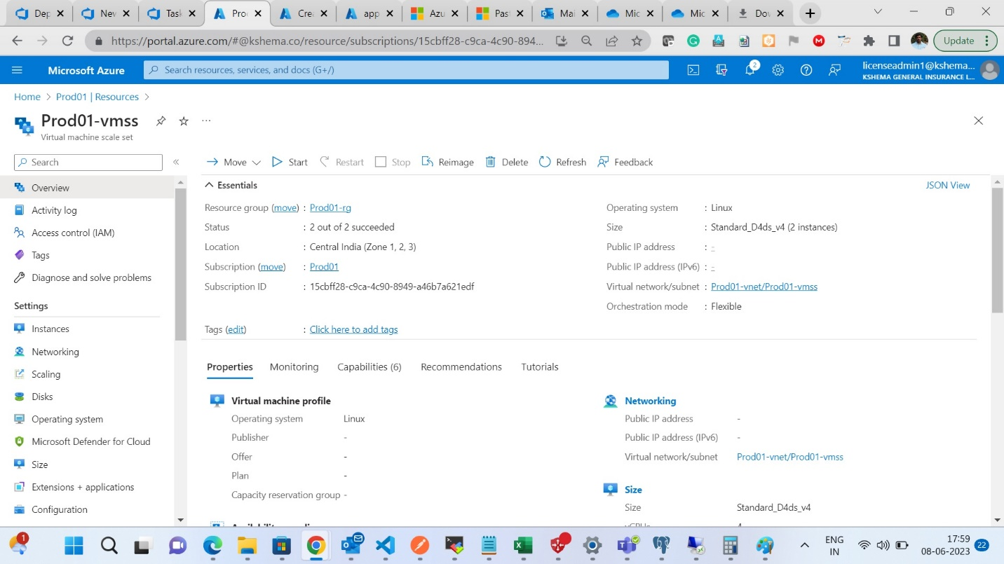



4. Click on Change Image Reference

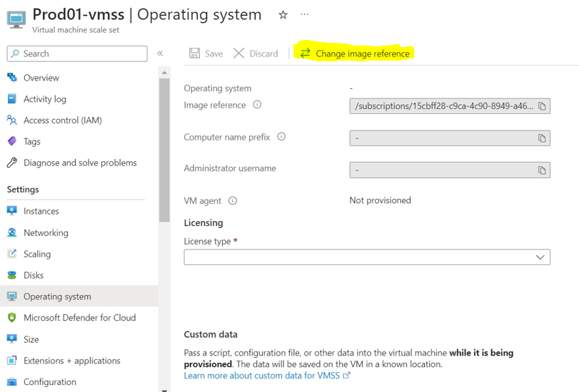

5. Fill the details in below mentioned screenshot. (Change Image Reference)

6. Select Instance options and select images and delete as shown below.

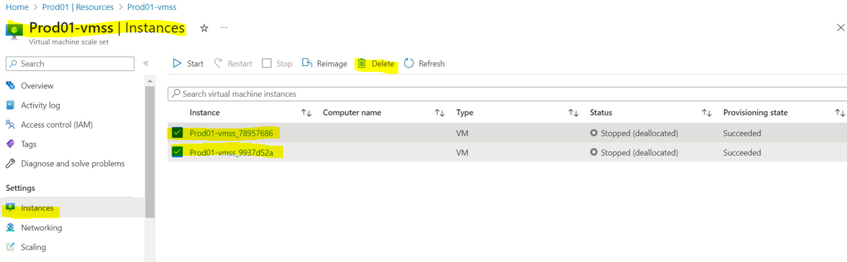

7.Select Scaling Tab, click on Manual scale and follow the below screen as shown below.

8. For Check click on Instances, here two instances created.

9.After vmss created, we need to deploy in DR vmss same process should be followed.

10. then we need to start base vm (52.172.229.191)

War Deploying in PROD Server

//sudo su

Opt/tomcat9/webapps

Here copy the files

________________________________________________